**DevOps and Cloud Job Roles and Responsibilities**

SDLC, SDLC phases, JIRA tool and Manual deployment.

* Note: Please use the class room video, this note will be a quick remainder of the discussion we had
* Traditional Approach and Problems

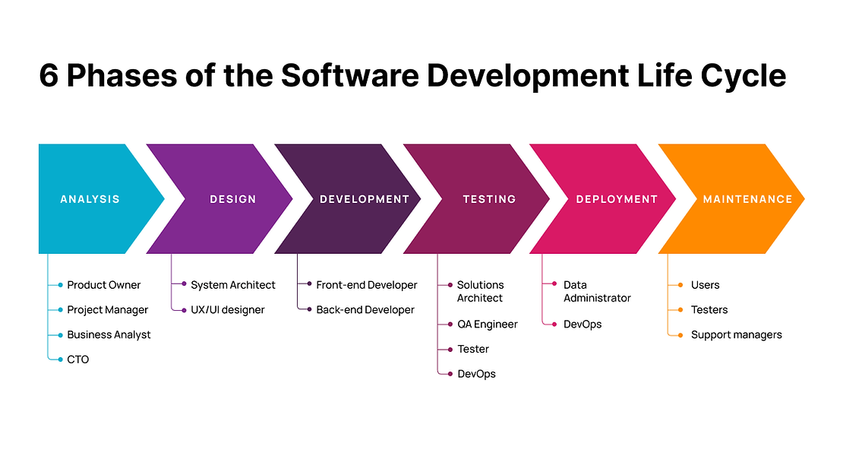  
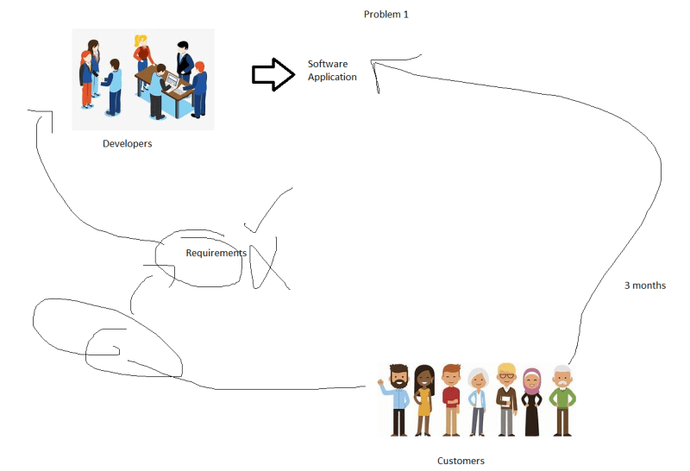  
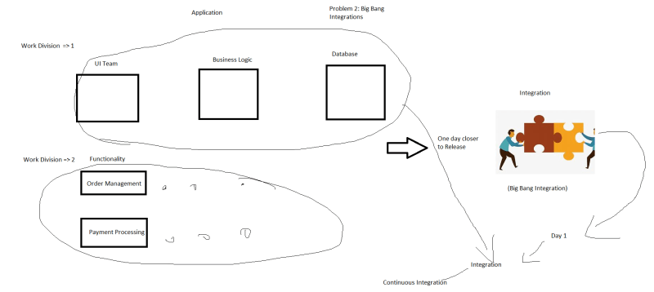  
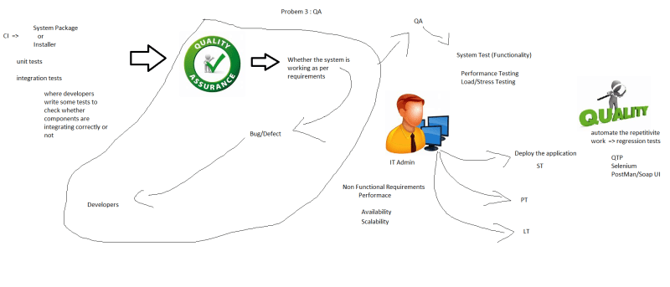

Organizational Expectation:

* + Consolidate all the work done by developers in one day and try to execute all sorts of possible tests and showcase the reports to the team when they start their day
  + For every change or set of changes done by the developers during their working hours try to give them feedback on how their code is behaving